Given two integer arrays inorder and postorder where inorder is the inorder traversal of a binary tree and postorder is the postorder traversal of the same tree, construct and return *the binary tree*.

**Example 1:**

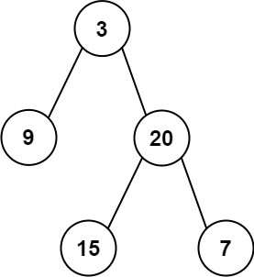

Input: inorder = [9,3,15,20,7], postorder = [9,15,7,20,3]  
Output: [3,9,20,null,null,15,7]

**Example 2:**

Input: inorder = [-1], postorder = [-1]  
Output: [-1]

**Constraints:**

* 1 <= inorder.length <= 3000
* postorder.length == inorder.length
* -3000 <= inorder[i], postorder[i] <= 3000
* inorder and postorder consist of **unique** values.
* Each value of postorder also appears in inorder.
* inorder is **guaranteed** to be the inorder traversal of the tree.
* postorder is **guaranteed** to be the postorder traversal of the tree.